**THE PIHA BEACH**

**Piha** is a coastal settlement in [West Auckland](https://en.wikipedia.org/wiki/West_Auckland,_New_Zealand), on the western coast of the [Auckland Region](https://en.wikipedia.org/wiki/Auckland_Region) in New Zealand. It is one of the most popular beaches in the area and a major day-trip destination for Aucklanders throughout the year, and especially in summer.

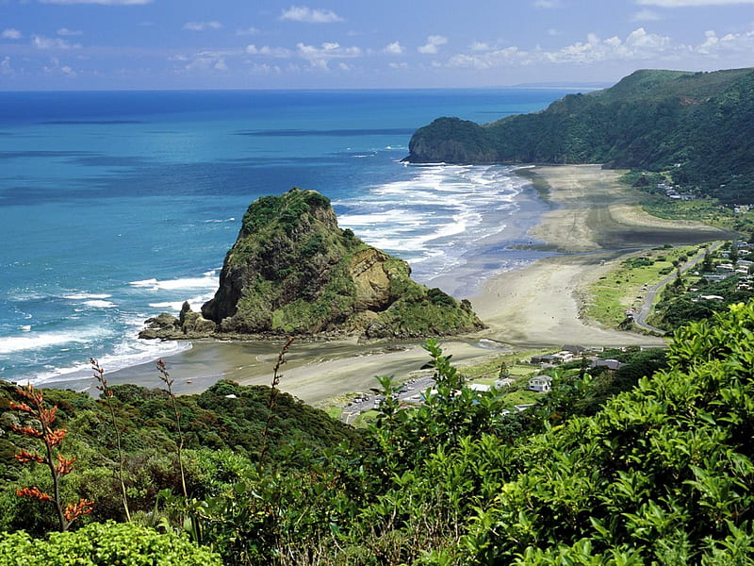

Piha is 39 kilometres west of [Auckland](https://en.wikipedia.org/wiki/Auckland) city centre, on the [Tasman Sea](https://en.wikipedia.org/wiki/Tasman_Sea) coast to the north of the [Manukau Harbour](https://en.wikipedia.org/wiki/Manukau_Harbour), on the western edge of the [Waitākere Ranges](https://en.wikipedia.org/wiki/Wait%C4%81kere_Ranges" \o "Waitākere Ranges). Immediately to the north of Piha is [Whites Beach](https://en.wikipedia.org/wiki/Whites_Beach), and immediately to the south is [Te Unuhanga-a-Rangitoto / Mercer Bay](https://en.wikipedia.org/wiki/Te_Unuhanga-a-Rangitoto_/_Mercer_Bay" \o "Te Unuhanga-a-Rangitoto / Mercer Bay); land access to both is only by foot. The nearest beaches accessible by road are [Karekare](https://en.wikipedia.org/wiki/Karekare,_New_Zealand" \o "Karekare, New Zealand) to the south, and [Anawhata](https://en.wikipedia.org/wiki/Anawhata) to the north.